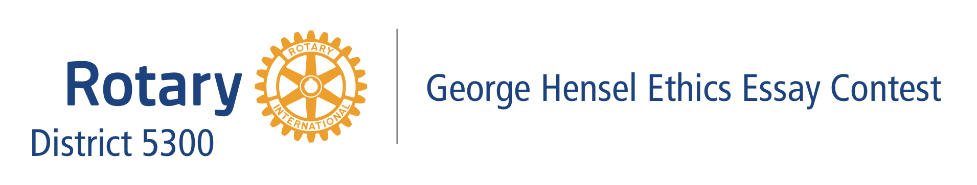
Date

Dear High School Principal:

Each year, Rotary International District 5300, through the participation of our Rotary club, gives the high school students in our area an opportunity for scholarship monetary awards by participating in the George R. Hensel Ethics Essay Contest.
This Vocational Service program is held throughout Rotary International District 5300 with students, 9th to 12th grades. The contest is held on two competition levels: first at the local Rotary club level, and second at the district level. The student who wins first place at the club level automatically advances to the district level.
The District scholarship awards are $3,000.00 for the first-place winner and $1,000 for his/her teacher. $500.00 for each of the three (3) runner-up winners and $200 for each of their teachers. Each winner also gets a certificate of appreciation, which the students treasure more than the monetary reward!
We have enclosed some flyers with the contest rules and information for the students and the official entry forms. You may also download these forms and information from the Rotary district website: https://district5300.org/service/youth-service/george-r-hensel-ethics-essay-contest/
We hope you will encourage your students to participate in this excellent scholarship program, which will allow them to express their views on the essential subject of ethics.
We will be looking forward to your participation in the George R. Hensel Ethics Essay Contest for 2023-2024. With Best Wishes.

Sincerely,

Name of Club Contest Chairperson
Rotary Club of _______________
Hensel Essay Contest Club Chairperson
Email
Phone

